**COMSATS University Islamabad (CUI)**

**Lab Terminal**

**Submitted to: Sir Bilal Bukhari**

**Submitted By: Ziyad Amjad**

**Reg No: FA21-BCS-057**

**Course: Topics in Computer Science**

**Date: 3 jan, 2025**

# Symbol table output:

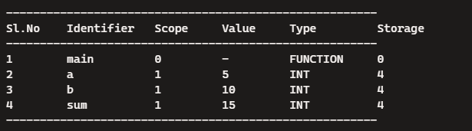

# Code generated output:

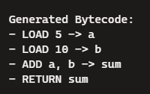

# Parsing output

